**EXPERIMENT 05:**

**Implementation of a 4 to 1 MUX using Gates and using IC 74LS153.**

**Objective:**

To familiarize student with basic working of multiplexer and implementation of 4x1 mux.

**Equipment / Tool:**

Trainer, IC 74LS04 (NOT), 74LS32 (OR), 74LS08 (AND), 74LS153 (4 TO 1 MUX).

**Background Theory:**

A MUX is a combinational circuit that can be used to select data and produce it at the output. They can be 2 to 1, 4 to 1, 8 to 1, 16 to 1, etc. It has a lot of applications. There are many scenarios in which we have to select a particular data and produce it at the output.

**Lab Tasks:**

* Write the truth table for a 2 to 1 MUX, design a circuit from it, implement it and verify the results.
* Write down the truth table for a 4 to 1 MUX, draw the circuit, implement it and verify the results.
* Use the IC 74LS153 (4 to 1 MUX) and verify the results.

**Procedure**

Following is the circuit for 2 to 1 MUX and truth table:

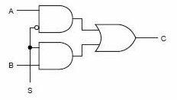

|  |  |  |  |
| --- | --- | --- | --- |
| **S** | **B** | **A** | **Y** |
| 0 | X | 0 | 0 |
| 0 | X | 1 | 1 |
| 1 | 0 | X | 0 |
| 1 | 1 | X | 1 |

**Circuit Diagrams:**

Draw the diagram of 4 to 1 MUX as follows:

Fill in the following Truth Table:

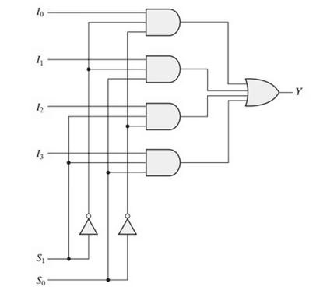

|  |  |  |  |  |  |  |
| --- | --- | --- | --- | --- | --- | --- |
| **S1** | **S0** | **X3** | **X2** | **X1** | **X0** | **Y** |
| 0 | 0 |  |  |  |  |  |
| 0 | 0 |  |  |  |  |  |
| 0 | 1 |  |  |  |  |  |
| 0 | 1 |  |  |  |  |  |
| 1 | 0 |  |  |  |  |  |
| 1 | 0 |  |  |  |  |  |
| 1 | 1 |  |  |  |  |  |
| 1 | 1 |  |  |  |  |  |

**Implementing using 74LS153:**

Following is the pin configuration extracted from the datasheet. DUAL-IN-LINE Package

**Function Table:**

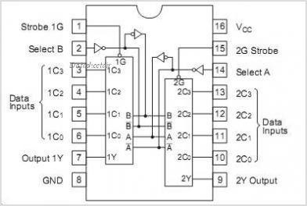

|  |  |  |  |  |  |  |  |
| --- | --- | --- | --- | --- | --- | --- | --- |
| **Select Inputs** | |  | **Data Inputs** | | | **Strobe** | **Output** |
| **B** | **A** | **C**  **0** | **C1** | **C2** | **C3** | **G** | **Y** |
| X | X | X | X | X | X | H | L |
| L | L | L | X | X | X | L | L |
| L | L | H | X | X | X | L | H |
| L | H | X | L | X | X | L | L |
| L | H | X | H | X | X | L | H |
| H | L | X | X | L | X | L | L |
| H | L | X | X | H | X | L | H |
| H | H | X | X | X | L | L | L |
| H | H | X | X | X | H | L | H |